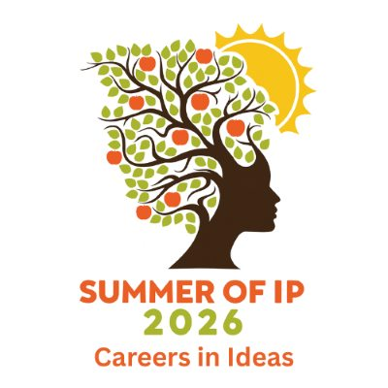

Careers in Ideas: Summer of IP 2026

Activity Suggestions and Resources

Contents

1 Careers in Ideas Resources Directory 2
2 Activity ideas 2
3 Insight evening sample timetable 3
4 Open day sample timetable 4

1 Careers in Ideas Resources Directory

Careers in Ideas has compiled a Resources Directory which provides IP professionals with information and resources to support them in outreach activities. It also contains resources which may be useful for signposting to students, parents, teachers and careers advisors.

- Part 1 is specifically targeted to IP Professionals and includes resources under the following headings:
- Introductory information about Careers in Ideas, and its Mentoring Hub
- Engaging with Outreach Work and Promoting Diversity in the IP Professions
- Resources for Recruitment
- Resources for use when visiting schools, universities, careers fairs and exhibitions.
- Part 2 includes resources for students, parents, teachers and careers advisors. These may also be useful for IP professionals for preparing presentations or signposting following an outreach activity.
- Part 3 includes useful resources from national and regional Intellectual Property Offices. These may also be useful for IP professionals for preparing presentations or signposting following an outreach activity.

2 Activity ideas

These can be adapted to suit your target audience (A-level students / university students / graduates) and the type of IP sector career you wish to showcase.
In the past, participants particularly appreciated interactive or practical, hands-on activities and opportunities to talk to IP professionals.
Informative:
- Introduction to IP / Types of IP
- IP careers/roles
- Life as a … IP paralegal / trainee / IP solicitor / IP barrister / patent attorney / TM attorney patent examiner / TM examiner, etc
- A typical day, types of tasks, etc
- Training process/exams
- Types of work
- Types of client
- IP solicitor vs patent/TM attorney vs patent/TM examiner
- Different IP roles at the UK IPO / EPO / EUIPO
- Different IP roles in the judicial system
- Role of a patent / TM examiner at the IPO or EPO or EUIPO
- Business support roles in the IP sector
- In-house vs private practice
- How to apply – qualifications/skills/experience required/desired
- Resources: Careers in Ideas, IP Careers, UK IPO, WIPO
- Highlights of an IP career
- Challenges of an IP career
- Equality, diversity and inclusion in the IP sector

Practical:

- Practical exercise – pairs / small groups – patent, TM or design task (for example claim drafting or freedom to operate assessment)
- Practical exercise – pairs / small groups – sort the post / prioritise tasks
- Break-out groups to explore types of IP in various products
- Break-out groups to work with trainee on a practical issue / exam-type question
- Mock hearing
- Research and presentation task
- Work experience opportunity

Interactive:

- Ask the panel – Q&A session
- Office tour
- Typical interview and assessments – have a go at one of the assessments
- CV and cover letter tips / workshop (ask students to bring their CV to compare)
- Mentoring session
- Networking session

3 Insight evening sample timetable

Time | What | Who
18:00 | Welcome to firm, Introductions, Health and Safety | Office Manager / HR
18:10 | What is IP? What are the types of IP? What are the roles? | Office Manager, HR or role rep
18:30 | Break-out groups to explore specific role via practical or interactive activity | Role reps or trainees
19:15 | Ask the panel – Q&A session  - Resources, eg Careers in Ideas, IP Careers, UKIPO, WIPO  - Next steps; Education / experience requirements; How to apply | Role rep, trainee, HR
20:00 | Finish

4 Open day sample timetable

Time | What | Who
10:00 | Welcome to firm, office show around, Health and Safety | Office Manager / HR
10:15 | Introduction to the firm and the industry | Office Manager, HR or role rep
11:00 | Trainee experience:  - How got into the industry  - What’s enjoyable / what’s challenging  - Exam process / experience | Trainee
12:00 | Working in the role:  - Typical day / type of tasks  - Practical small group activity to illustrate role | Qualified/experienced role rep
13:00 | Lunch | All office
14:00 | Meet with trainee in their practice area :  - Educational/work background – how helps in role  - Types of work / clients | Trainee
15:00 | Applying to the industry  - Resources, eg Careers in Ideas, IP Careers, UKIPO, WIPO  - Typical interview and assessments + have a go  - CV & cover letter tips (ask students to bring their CV) | HR / those involved in recruitment
16:00 | Finish

